**Curriculum Vitae**

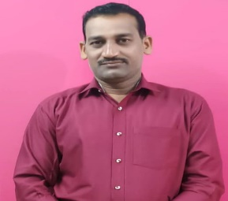

**Name- Srikanta Patel**

Contact Number-7873183084,8260373833

Email – [patelsrikanta931@gmail.com](mailto:patelsrikanta931@gmail.com)

**Personal Profile**

Name- Srikanta Patel

Date of Birth- 22.04.1979

Father’s Name- Mr. Chudamani Patel

Mother’s Name-Mrs. Kuntala Patel

Sex- Male

Category- OBC

Religion- Hinduism

Nationality- Indian

Marital Status- Married

Languages known- Odia,English, Hindi

Adress- At/Po- Badbahal Via Kundukela

P.S- Bhasma, Dist-Sundargarh

Pin-770019

State-Odisha

**Academic Credentials**

|  |  |  |  |  |
| --- | --- | --- | --- | --- |
| **Exam Passed** | **Board/University** | **Year of Passing** | **Division** | **% of Marks** |
| 10th | BSE, Orissa | 1995 | 3rd | 45.21% |
| +2 | CHSE, Orissa | 1997 | 2nd | 49.09% |
| U.G(History) | Sambalpur University | 2000 | 2nd | 48.81% |
| P.G(History) | Sambalpur University | 2002 | 1st | 63% |
| M.phil(History) | Sambalpur University | 2003 | 1st | 62.08% |

**Work Experience**

* 11 Years of teaching experience in Degree Government college Sundargarh in deptt of History
* Currently I am angaged as a Guest faculty in the same institution (Degree govt college,Sundargarh)

**Favourite Pastime**

* Reading Books
* Watching Suspense thriller movies

**Declaration**

I do here by declare that the above furnished information is completely true and correct to the best of knowledge.

Place- Sundargarh

Date- Signature